Agenda

*Date: 05/19/13*

*Location: CSE Labs*

*Actual Time: 3pm - 6pm (ish)*

*Planned Length: ?*

***Silly Picture of the Week: A combative sungod! Rawr!***

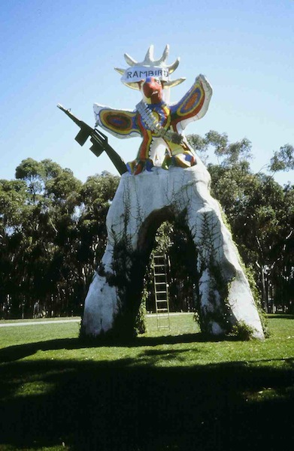

***Please add and comment on anything and everything in the agenda!***

|  |  |  |  |
| --- | --- | --- | --- |
| Team Member(s) | Topic | Time | Goals |
| Sorin | Announcements | 5 min | All team members are updated on new developments |
| Backend | Updates/ Finish tasks |  | Updates on last week’s progress/ overall progress. Finish tasks that need finishing |
| Backend | Next week’s tasks |  | Set goals for next week; assign tasks; update scrumy |
| Sorin | Recap and Next steps | 5 min. | Meeting progress/ goal accomplishment is recapped. Next steps are outlined so that every team member goes into next week knowing what they are expected to contribute |

**Time total:** ?

# Notes

**Front End Summary**

* Can pass in horizontal and vertical image to pass in photos

Front end and back end interact through submission form.Question for the future: How will the backend interact with the controller? How will the controller interact with the backend?

Both are in python so the UI can probably call the controller methods directly.

**Back End Summary**

* Kevin and Sorin: Meeting on tuesday to review code, haven’t done much yet
* Brian and David: no significant progress
* Paul: updated wiki, still not really getting osx install working so well
* Shannon and JT: JT said on wednesday that he tested the structure and it worked fine, I’m getting weird indentation errors.

**What is the backend did today:**

* Sorin: Finished UML Diagram
* Brian: researched more pupil detection (almost working)
* JT: refactored eye detection and eye remove
* Shannon: Drafted controller code, fixed errors
* Paul: almost got mac install steps working.

**What is the frontend doing today:**

* Welcome/Upload page - Confirmation button :
  + 1. Error checks
    - If false:
      * 1. null error check
        + user just presses confirm button without touching anything else
        + throw alert window

Message: “Please choose your vertical and horizontal images.”

* + - * 2. Missing VERTICAL image
        + alert window pop-up

Message: “Please choose your vertical image”.

* + - * 3. Missing HORIZONTAL image
        + alert window pop-up

Message: “Please choose your horizontal image”.

* + 2. Controller - run its code on images
    - btn click = run controller method
      * parameters (horizontal image string path, vert. img. str. path)
      * return = error string or
    - run controller method (takes in both images as paramaters)
      * + take return objects (should be two images, one horixontal one verical)
        + open next page and put both objects and widgets onto it
  + Front-End Research links:

1. <http://www.blog.pythonlibrary.org/2012/07/12/wxpython-how-to-create-a-generic-wizard/>
2. <http://scrumy.com/DVS-spring-2013>
3. <http://wiki.wxpython.org/Passing%20Arguments%20to%20Callbacks>

# Summary

* Backend: made some progress but it doesn’t look like we’ll be able to move on to sclera detection this week. We’ll be pushing the schedule back.

# TODO

* For backend: see scrumy.

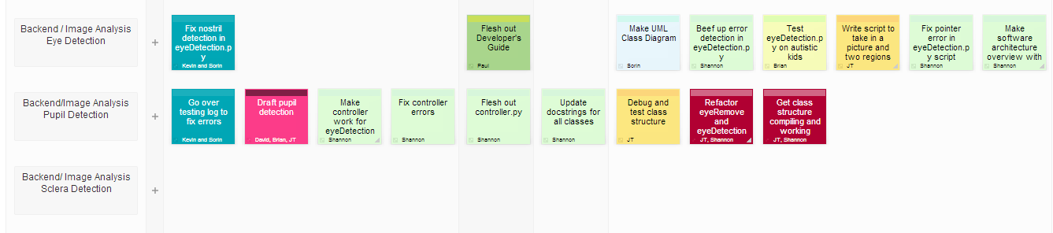

* For Front-end: see scrumy.

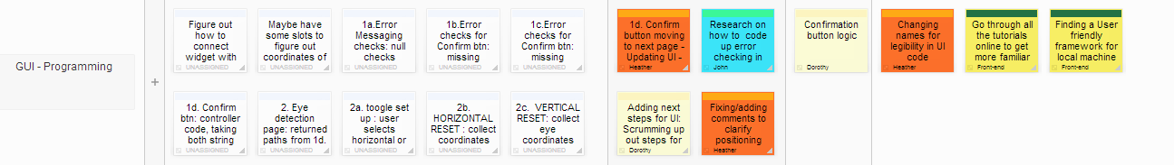

# 

# Whiteboard Pics

None for today